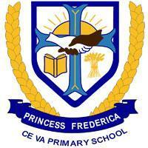
Princess Frederica Primary School
Termly Overview
Year 5
Spring 2023
Class teachers: Mrs Brookes & Ms Foster, Miss Redhead and support teacher Ms Sayers.
We hope you all had a wonderful Christmas break. We’d like to wish you all a warm welcome back to school. As always, we have much planned for the term ahead, and the following overview will outline what your child is learning about in class, as well as some important dates to note for this term. More detailed information about what children will be learning will be shared by class teachers through knowledge organisers which are also posted on the school website.

Important dates for your diary
Spring 1 : Monday 8th January - Friday 9th February at 3:30pm

- School Improvement Briefing for parents is at 9:00am on Wednesday 7th February
- 5 Birch’s trip to the Ragged Museum is on Wednesday 7th February
- 5 Ash’s trip to the Ragged Museum is on Friday 9th February
- We break up for half term on Friday 9th February at 3:30pm and we return on Monday 19th February

Spring 2: Monday 19th February - Thursday 28th March at 1:30pm
- Friday 1st March to Friday 8th March is Book Week and Thursday 7th March is World Book Day
- Parent consultation meetings will take place during the two weeks beginning 11th March
- Easter service at St Marks is at 10:00am on Thursday 28th March
- We break up for the term on Thursday 28th March at 1:30pm

Residential Trip to Ironbridge: 24th June - 28th June

Our Christian Values
As always we will be focusing on teaching an engaging broad curriculum which will involve reading a whole variety of different genres of texts, as well as ‘living our Christian values’: Growth, Unity, Kindness and Faith

At the centre of the school we have our school vision “Belonging, learning and growth for life in all its fullness.”

For more detailed information on our school vision, values and ethos we encourage you to visit our website: http://www.princessfrederica.brent.sch.uk/

Learning in our class this term
Our curriculum is designed to develop children’s character, intellect and curiosity. We have high aspirations for our children and aim to offer them a broad, challenging, engaging and diverse curriculum.
By the time children leave our school they will:
- Be kind, confident, well-mannered, thoughtful members of society who embody our Christian values.
- Speak confidently and in Standard English, with a broad range of vocabulary, in formal situations, for example children should be able to argue a point and greet a visitor.
- Have knowledge of a core set of books and poetry that they can make links to and draw upon.
- Have a broad general knowledge and understanding of the world for example of historical facts, geographical sense of place and religions.
- Understand the cultural and historical influences that have shaped this area of London.
- Be ambitious for their futures, expecting that he or she can follow career paths that take them onto higher education such as university or an apprenticeship.
- Enjoy and appreciate the arts and be able to participate in performances, for example music, poetry, dance and drama.
- Understand their body, how to keep it healthy and enjoy participating in sporting activities.
- Have healthy relationships with an age-appropriate understanding of sex education.
- Be able to keep themselves safe (both online and on the streets) and know how to avoid confrontation and resolve disputes peacefully through restorative approaches.
- Have a love of learning and self-efficacy around studying.
- Be passionate about looking after our world and take active responsibility for making a difference in our world.
- Understand and value the concepts of Global Human Values and contribute positively to our community.
- Respect each other regardless of race, religion, ethnicity, culture, gender, disability and wealth.
- Be courageous advocates for the causes they believe in.
- Be anti-racist and call out injustice.
Below is more information about the subjects we will be covering this term (please also refer to our knowledge organisers on the school website).
- Geography: Biomes, Rainforests and the Arctic
- History: Local History study: A day in the life of a Victorian child
- Religious Education: Sikhism; what happens in churches during Lent and Easter
- Science: Earth in Space; Materials and sustainability
- Computing: Spreadsheets and databases
- Art/DT: 3D sculptures and Cam toys
- Relationships, sex and health education: Keeping Safe: cyber bullying, staying safe online, basic first aid
- Texts we will be reading as a whole class are: The boy at the back of the class by Onjali Rauf, How to train your dragon by Cressida Cowell, Orchid book of Greek myths and from around the world, A place called perfect by Helena Duggan, Way past winter by Kiran Hargrave,

Learning objectives
This term children in Year 5 will be working on the following objectives in the core subjects:

Mathematics
I can:

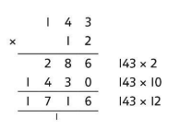
- I can multiply numbers up to 4 digits by a one- or two-digit number using a formal written method
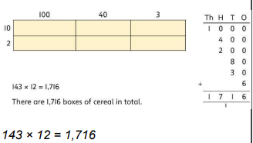
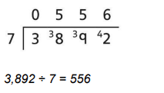
- I can divide numbers up to 4 digits by a one-digit number using the formal written method

- I can recognise and use square numbers and their roots, and the notation for squared (2) and square root

- I can read and write decimals as fractions

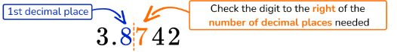
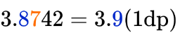
- I can round decimals with two decimal places to the nearest whole number and to one decimal place

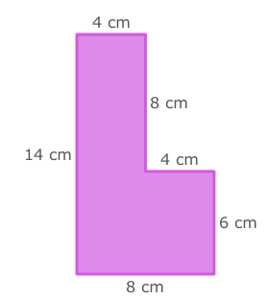
- I can measure and calculate the perimeter of composite rectilinear shapes in centimetres and metres

Reading
I can:
- identify how an author’s language such as descriptive phrases impact and effect the reader
- make inferences about a character’s thoughts and feelings
- reading for fluency
- formulate an opinion and give reasoned justification for my views
- summarising key points

Writing
I can:
- assessing the effectiveness of my own and others’ writing
- proof read for spelling and punctuation errors
- use commas to clarify meaning or avoid ambiguity in my writing (to separate main and subordinate clauses)
- use a variety of tenses correctly in my writing
- spell most homophones correctly

Home-learning will include opportunities to practise some of these objectives but if you and your child are not sure what they mean please make an appointment to speak to me before or after school.
Home-learning and how parents can help
Children work very hard at school during the day so we want to keep home-learning simple and easy to manage. Parents can be a great help if they talk to their children about their learning and set up a routine every night. Little and often is best.
Reading
It is vital that children practise their reading at home by being heard by an adult or older sibling. This is just as important for older children who are decoding texts fluently – they may be able to read the words, but they also need opportunities to discuss the meaning of the texts they are reading as often as possible.

Key Stage Two (Years 3-6)
Children take home a book of their choice (banded book) and a reading diary. Teachers and teaching assistants ensure that the level of the book the child takes home is appropriate and carefully monitor the amount children are reading at home.

Children in KS2 should read for half an hour every day. They can record their reading comments in their reading journal and you should sign and add any more comments to show your child has read to you or another adult/older sibling. Reading books should be brought into school each morning along with the reading diary. We encourage children to read a wide range of authors and text types which they find in everyday life, as well as books.

Mathematics
KIRFS (Key Instant Recall Facts)
This year we are going to continue to help children improve their mental maths skills, which are essential to becoming confident mathematicians.
Each half term children will be given a list of Key instant Recall Facts to practise and learn at home as well as in school. It is important that they know these thoroughly and can recall specific facts instantly. Whilst children have a wide range of abilities in mathematics, the key instant recall facts are a set of facts that need to be learnt off by heart. They build on each other year on year. Again, we stress that the children must aim to know the facts inside out, back to front and with instant recall. Children should practise these facts every night for about 10 minutes. Little and often is the key. Each child will be quizzed on the facts during the half term so teachers can monitor their progress.

Mathletics
Each week the children are set activities on Mathletics which are related to their class mathematics work. The tasks should not take longer than 15 minutes and once completed, children can use Live Mathletics to compete against other children in quick fire recall questions.
Spellings
Your child will receive lists of useful words every week. These words are linked to the spelling pattern or family taught during that week in school. Children will need to practise these for 5 to 10 minutes each night. Little and often is most effective. We are no longer using Spelling Shed nor having a weekly spelling test. As the term goes on they will also have a little red book which will contain spellings individual to the child.

Projects
Each half term the children will be set a project. This will be set around different curriculum subjects and based on learning in class, so that children can further their learning about a particular subject. At the end of each half term the children will present their project to their class. As the last half term of the year is so busy, there will not be a project set for June and July.

Weekly events
Library is on Monday
Music is on Wednesday
Year 5: PE is on Tuesday and Friday – this term the children will be focusing on fitness circuits and striking and fielding.
PE Uniform: Children should wear their PE kit to school on PE days. The PE uniform is a T shirt with embroidered crest in their house colour, black shorts or grey jogging bottoms and black plimsolls or trainers.
Best wishes,

Mrs Brookes, Ms Foster & Miss Redhead

